ASSIGNMENT NO.12
TITLE: Write a program to implement MongoDB database connectivity with any front end
language to implement Database navigation operations(Add, delete, edit etc.)

PROBLEM STATEMENT: Write a Java program to connect to MongoDB Database named “Institute” and Collection named “Students”. Perform following operations on the database through java program.

OBJECTIVES:
- To understand MongoDB database Connectivity
- Use Front End tool like Java to do MongoDB database Connectivity

OUTCOMES:
- Students will apply the front end Tool like Java
- Students will be able to write program for given requirements using Mongodb and Java.

SOF TWARE & HARDWARE REQUIREMENTS:
- 64-bit Open source Linux or its derivative
- MongoDB Server

IMPLEMENTATION:

import com.mongodb.client.MongoDatabase;
import com.mongodb.client.model.Updates;
import com.mongodb.client.MongoCollection;
import com.mongodb.client.FindIterable;
import org.bson.Document;
import com.mongodb.MongoClient;
import java.util.Scanner;
import java.util.Iterator;

public class MongoJava {
private static Scanner sc;
public static void main (String args[]) {
MongoCollection<Document> collection=null;
try {
// Creating a Mongo client
MongoClient mongo = new MongoClient( "localhost" , 27017 );
// Accessing the database
MongoDatabase database = mongo.getDatabase("Institute");
System.out.println("Connected to the database successfully");
//Creating a collection
// database.createCollection("Students");
//System.out.println("Collection Students created successfully");
// Retrieving a collection
collection = database.getCollection("Students");
System.out.println("Collection Students selected successfully");

sc = new Scanner(System.in);
int choice;
do {
System.out.println("\n1. Insert Document \n2. Delete Document \n3. Update Document \n4. Display All \n5. Display marks>75 \n6. Exit \nEnter your choice :");
choice = sc.nextInt();
switch (choice) {
case 1:insert(collection);
break;
case 2: deletedoc(collection);
break;
case 3: updatedoc(collection);
break;
case 4: displayAll(collection);
break;
case 5:display(collection);
break;
case 6: System.out.println("Exiting Program");
System.exit(0);
break;
default:
System.out.println(choice + " is not a valid Menu Option! Please Select Another.");

}
}while(choice != 6 /*Exit loop when choice is 6*/);
}
catch(Exception ex){
ex.printStackTrace();
}
}
public static void insert(MongoCollection<Document> collection) {
System.out.println("Inserting document");
Document document = new Document();
Scanner sc=new Scanner(System.in);
System.out.println("Enter roll no:");
int rollno = sc.nextInt();
System.out.println("Enter name:");
String name= sc.next();
System.out.println("Enter class:");
String classs=sc.next();
System.out.println("Enter marks:");
int marks= sc.nextInt();
System.out.println("Enter technical interests:");
String techint=sc.next();
document.append("roll_no",rollno);
document.append("name",name);
document.append("class",classs);
document.append("marks",marks);
document.append("technical_interests",techint);
collection.insertOne(document);
System.out.println("Document inserted successfully");
}
public static void deletedoc(MongoCollection<Document> collection) {
System.out.println("Deleting document");
Document document = new Document();
System.out.println("Enter roll no:");
Scanner sc=new Scanner(System.in);
int rollno= sc.nextInt();
document.put("roll_no",rollno);
collection.deleteOne(document);
System.out.println("Document deleted successfully");
}
public static void updatedoc(MongoCollection<Document> collection) {
System.out.println("Updating document");

Document newdocument = new Document();
System.out.println("Enter roll no:");
Scanner sc=new Scanner(System.in);
int rollno = sc.nextInt();
newdocument.put("roll_no",rollno);
System.out.println("Enter New marks:");
int marks = sc.nextInt();
collection.updateOne(newdocument,Updates.set("marks", marks));
}

public static void display(MongoCollection<Document> collection) {
System.out.println("Displaying documents in collection having marks greater than 75");
// Getting the iterable object
Document query=new Document();
query.append("marks",new Document().append("$gt", 75));
FindIterable<Document> iterDoc = collection.find(query);
// Getting the ite4rator
Iterator it = iterDoc.iterator();
while (it.hasNext()) {
System.out.println(it.next());
}
}
public static void displayAll(MongoCollection<Document> collection) {
System.out.println("Displaying all documents in collection");
// Getting the iterable object
FindIterable<Document> iterDoc = collection.find();
int i = 1;
// Getting the ite4rator
Iterator it = iterDoc.iterator();
while (it.hasNext()) {
System.out.println(it.next());
i++;
}
}
}
1.Display all records from Collection Students.
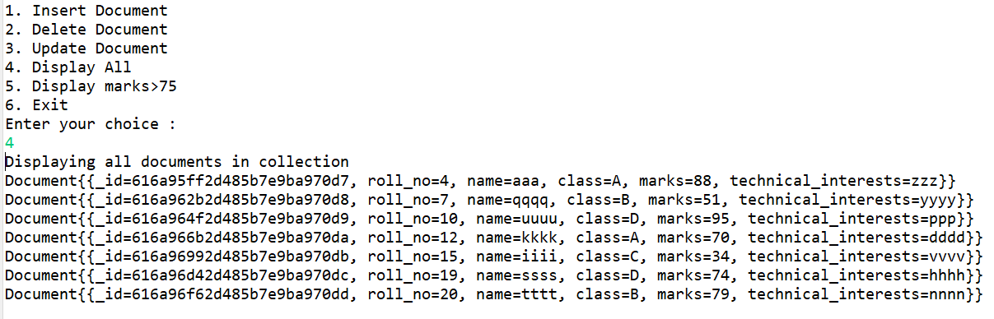
2. Insert records in collection students containing fields Stu_RollNo,Stu_Name, Class, Marks, Technical_Interests.
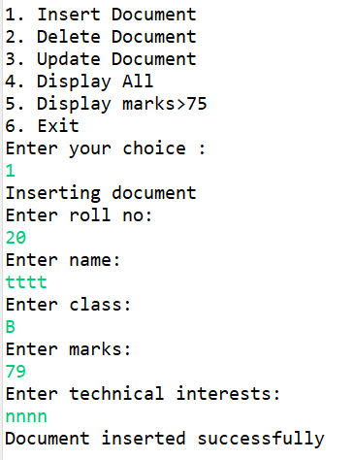
3. Delete the record of student having RollNo 10 from the collection.
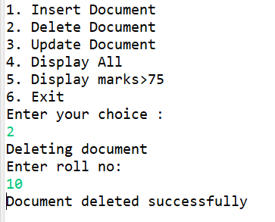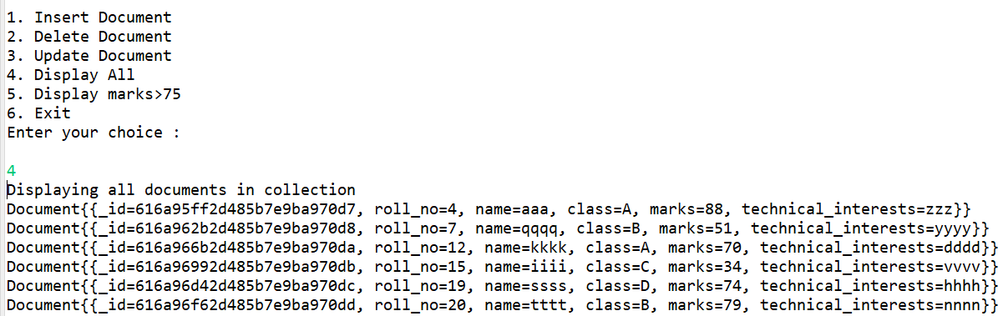
4. Update the record of student with RollNo 20 by changing Marks from
50 to 60.
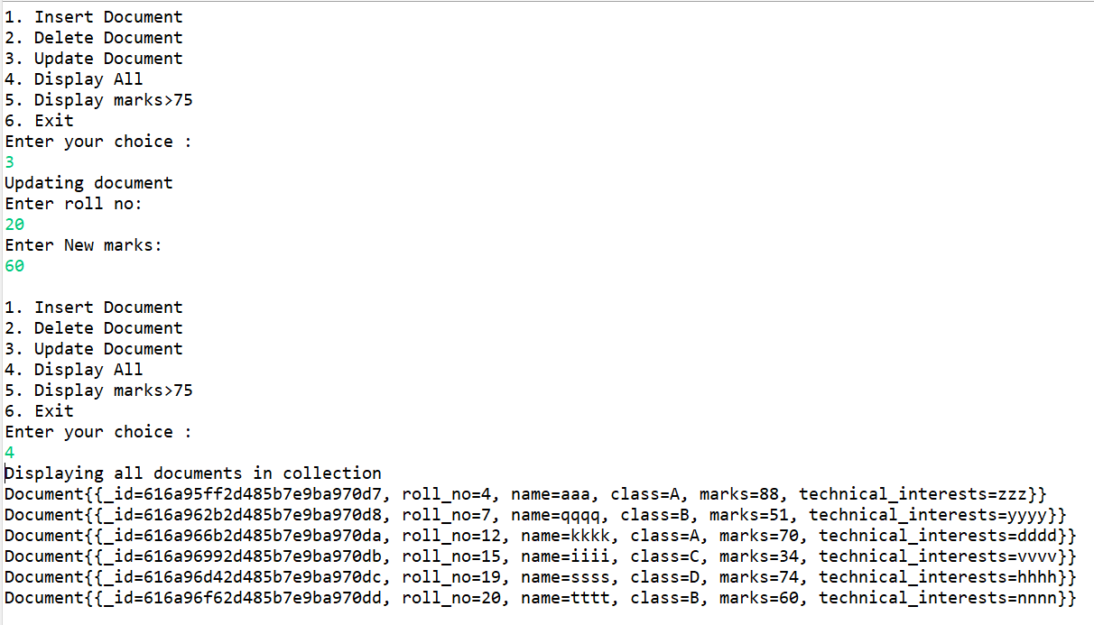

CONCLUSION:

